**Experiment 6:**

Harmonic Oscillator

Part II. Physical Pendulum

**Name:** Omar Ozgur

**Date:** November 16, 2015 (11/16/15)

**Lab:** Section 1, Monday 9am

**TA:** Hector Garcia

**Lab Partner(s):** Christie Matthews, Fiona Guo

**Introduction**

The purpose of this experiment was to explore the effects of damping and driving forces on a harmonic oscillator. In order to perform the experiment, a metallic pendulum was attached to a rotation sensor so that the angle of the pendulum relative to the vertical axis could be recorded with a data acquisition system. To prepare for driven oscillation, one end of a spring was attached to a wave driver, and the other end was attached to a wheel on the rotation sensor, so that changes in the spring’s tension would result in oscillatory motion of the pendulum.

Undamped oscillatory motion could be observed by displacing the pendulum by a small angle from its equilibrium position. Based on the time trace for the system, the undamped oscillation frequency “f0” could be determined by equation 1.0 below, where “n” refers to the number of successive amplitudes that were used, and “ $Δt$” refers to the difference in time between the first and last amplitudes that were used in the estimate. The same data could be used in equation 1.1 to determine the uncertainty “ $δf_{0}$”. Equation 1.1 is based on a general formula for determining the uncertainty of a value based on a collection of data points. By utilizing as much data as possible, the uncertainty can be minimized.

$f_{0}=\frac{n-1}{Δt}$ (Eq. 1.0)

$δf_{0}=\frac{1}{\sqrt{n}}\sqrt{\frac{1}{n-1}\sum_{i=1}^{n}{{\left(f_{i}-{f_{0}}_{best}\right)}^{2}}}$ (Eq. 1.1)

In order to demonstrate the effects of damping on the system, two magnets were set on opposite sides of the pendulum so that the pendulum could swing freely between them. During oscillation of the pendulum, the magnets caused induced currents in the metal, which produced a damping force on the system. By varying the distances of the magnets, the damping coefficient could be adjusted to demonstrate underdamped, overdamped, and critically-damped motion.

The magnet gap that produced critically-damped motion was determined by first setting the magnets close enough to produce overdamping, and then widening the gap by increments of 1 millimeter until the boundary between underdamping and overdamping could be found. Each time the gap was widened, the “scope” feature in Capstone was used to visually determine if the direction of the pendulum’s velocity would change during oscillation. The visual data was verified by numerical data in order to determine the magnet gap that would produce critical damping. The uncertainty in the distance measurement was ±1mm based on the ruler that was used. Data from the critically-damped case was used to find the damping time “ $τ$” of the system.

In order to explore the effects of various driving frequencies on the damped, harmonic oscillator, the wave driver was initially set to the frequency “f0” that was determined based on the original undamped oscillatory motion. In order to determine the driven resonance frequency of the system, Lissajous figures were created with the Capstone software based on recorded angles and output voltages that were recorded during oscillatory motion. This allowed for the creation of elliptical parametric plots that indicated the frequency’s deviation from the resonance frequency. If the ellipse was tilted down to the right, it indicated that the frequency was greater than the resonance frequency. The opposite was true if the ellipse was tilted down to the left. Large amounts of tilting indicated large deviations from resonance, while small amounts indicated small deviations. Based on this information, the diving frequency of the system was slightly altered until a Lissajous figure could be created so that the parametric plot produced a symmetrical ellipse, which indicated that the resonance frequency was found. In order to determine the uncertainty in the resonance frequency, the driving frequency was changed by the maximum amount that would not cause a noticeable change in the generated Lissajous figure.

One method to determine the quality factor “Q” for the system requires the calculation of the damping time “ $τ$” based on the ratios of amplitudes of successive maxima in recorded data. This can be done using equations 1.2 and 1.3, where “ $θ$” refers to the angle of the pendulum with respect to the vertical axis, and “ $T$” is the time between successive maxima. The uncertainty could be calculated by using equation 1.4, which requires the calculation of the damping time “ $τ_{i}$” between each pair of “n” maxima.

$\frac{θ(t+T)}{θ(t)}=\frac{e^{-\frac{t+T}{τ}}}{e^{-\frac{t}{τ}}}=e^{-\frac{T}{τ}}$ (Eq. 1.2)

$τ=-\frac{T}{ln⁡(\frac{θ(t+T)}{θ(t)})}$ (Eq. 1.3)

$δτ=\frac{1}{\sqrt{n}}\sqrt{\frac{1}{n-1}\sum_{i=1}^{n}{{\left(τ_{i}-τ_{best}\right)}^{2}}}$ (Eq. 1.4)

The calculation of damping time “ $τ$” allows for the calculation of “Q” in equation 1.5, where “ $ω_{R}$” refers to the resonance frequency that was found based on information from generated Lissajous figures. The uncertainty could be calculated by using equation 1.8, which is based on general uncertainty equations 1.6 and 1.7.

$Q=\frac{1}{2}τω_{R}$ (Eq. 1.5)

$If f=Ax: δf=|A|δx$ (Eq. 1.6)

$If f=xy: \frac{δf}{|f_{best}|}=\sqrt{{\left(\frac{δx}{|x_{best}|}\right)}^{2}+{\left(\frac{δy}{|y_{best}|}\right)}^{2}}$ (Eq. 1.7)

$δQ= \left|\frac{1}{2}\right||Q_{best}|\sqrt{{\left(\frac{δτ}{|τ_{best}\}}\right)}^{2}+{\left(\frac{δω_{R}}{|{ω_{R}}_{best}|}\right)}^{2}}$ (Eq. 1.8)

Another method for calculating “Q” is to create a graph that relates the pendulum’s oscillation amplitude to its frequency based on a range of driving frequencies around resonance. This data can be used to show a resonance curve for the system. The width of resonance “ $Δω$” can be found by taking the width of the curve at a height of 1/ $\sqrt{2}$ times the maximum amplitude. The uncertainty “ $δΔω$” is based on the amount of data that was used to produce the plot. One way to estimate uncertainty is based on the distance of estimated frequency values along the curve to the nearest recorded values. This resonance data can be used in equation 1.9 to find “Q”.

$Q=\frac{ω_{R}}{Δω}$ (Eq. 1.9)

$If f=\frac{x}{y}: \frac{δf}{|f_{best}|}=\sqrt{{\left(\frac{δx}{|x_{best}|}\right)}^{2}+{\left(\frac{δy}{|y_{best}|}\right)}^{2}}$ (Eq. 2.0)

$δQ=|Q_{best}|\sqrt{{\left(\frac{δω_{R}}{|{ω_{R}}_{best}|}\right)}^{2}+{\left(\frac{δΔω}{|Δω_{best}|}\right)}^{2}}$ (Eq. 2.1)

**Experimental Results and Data Analysis**

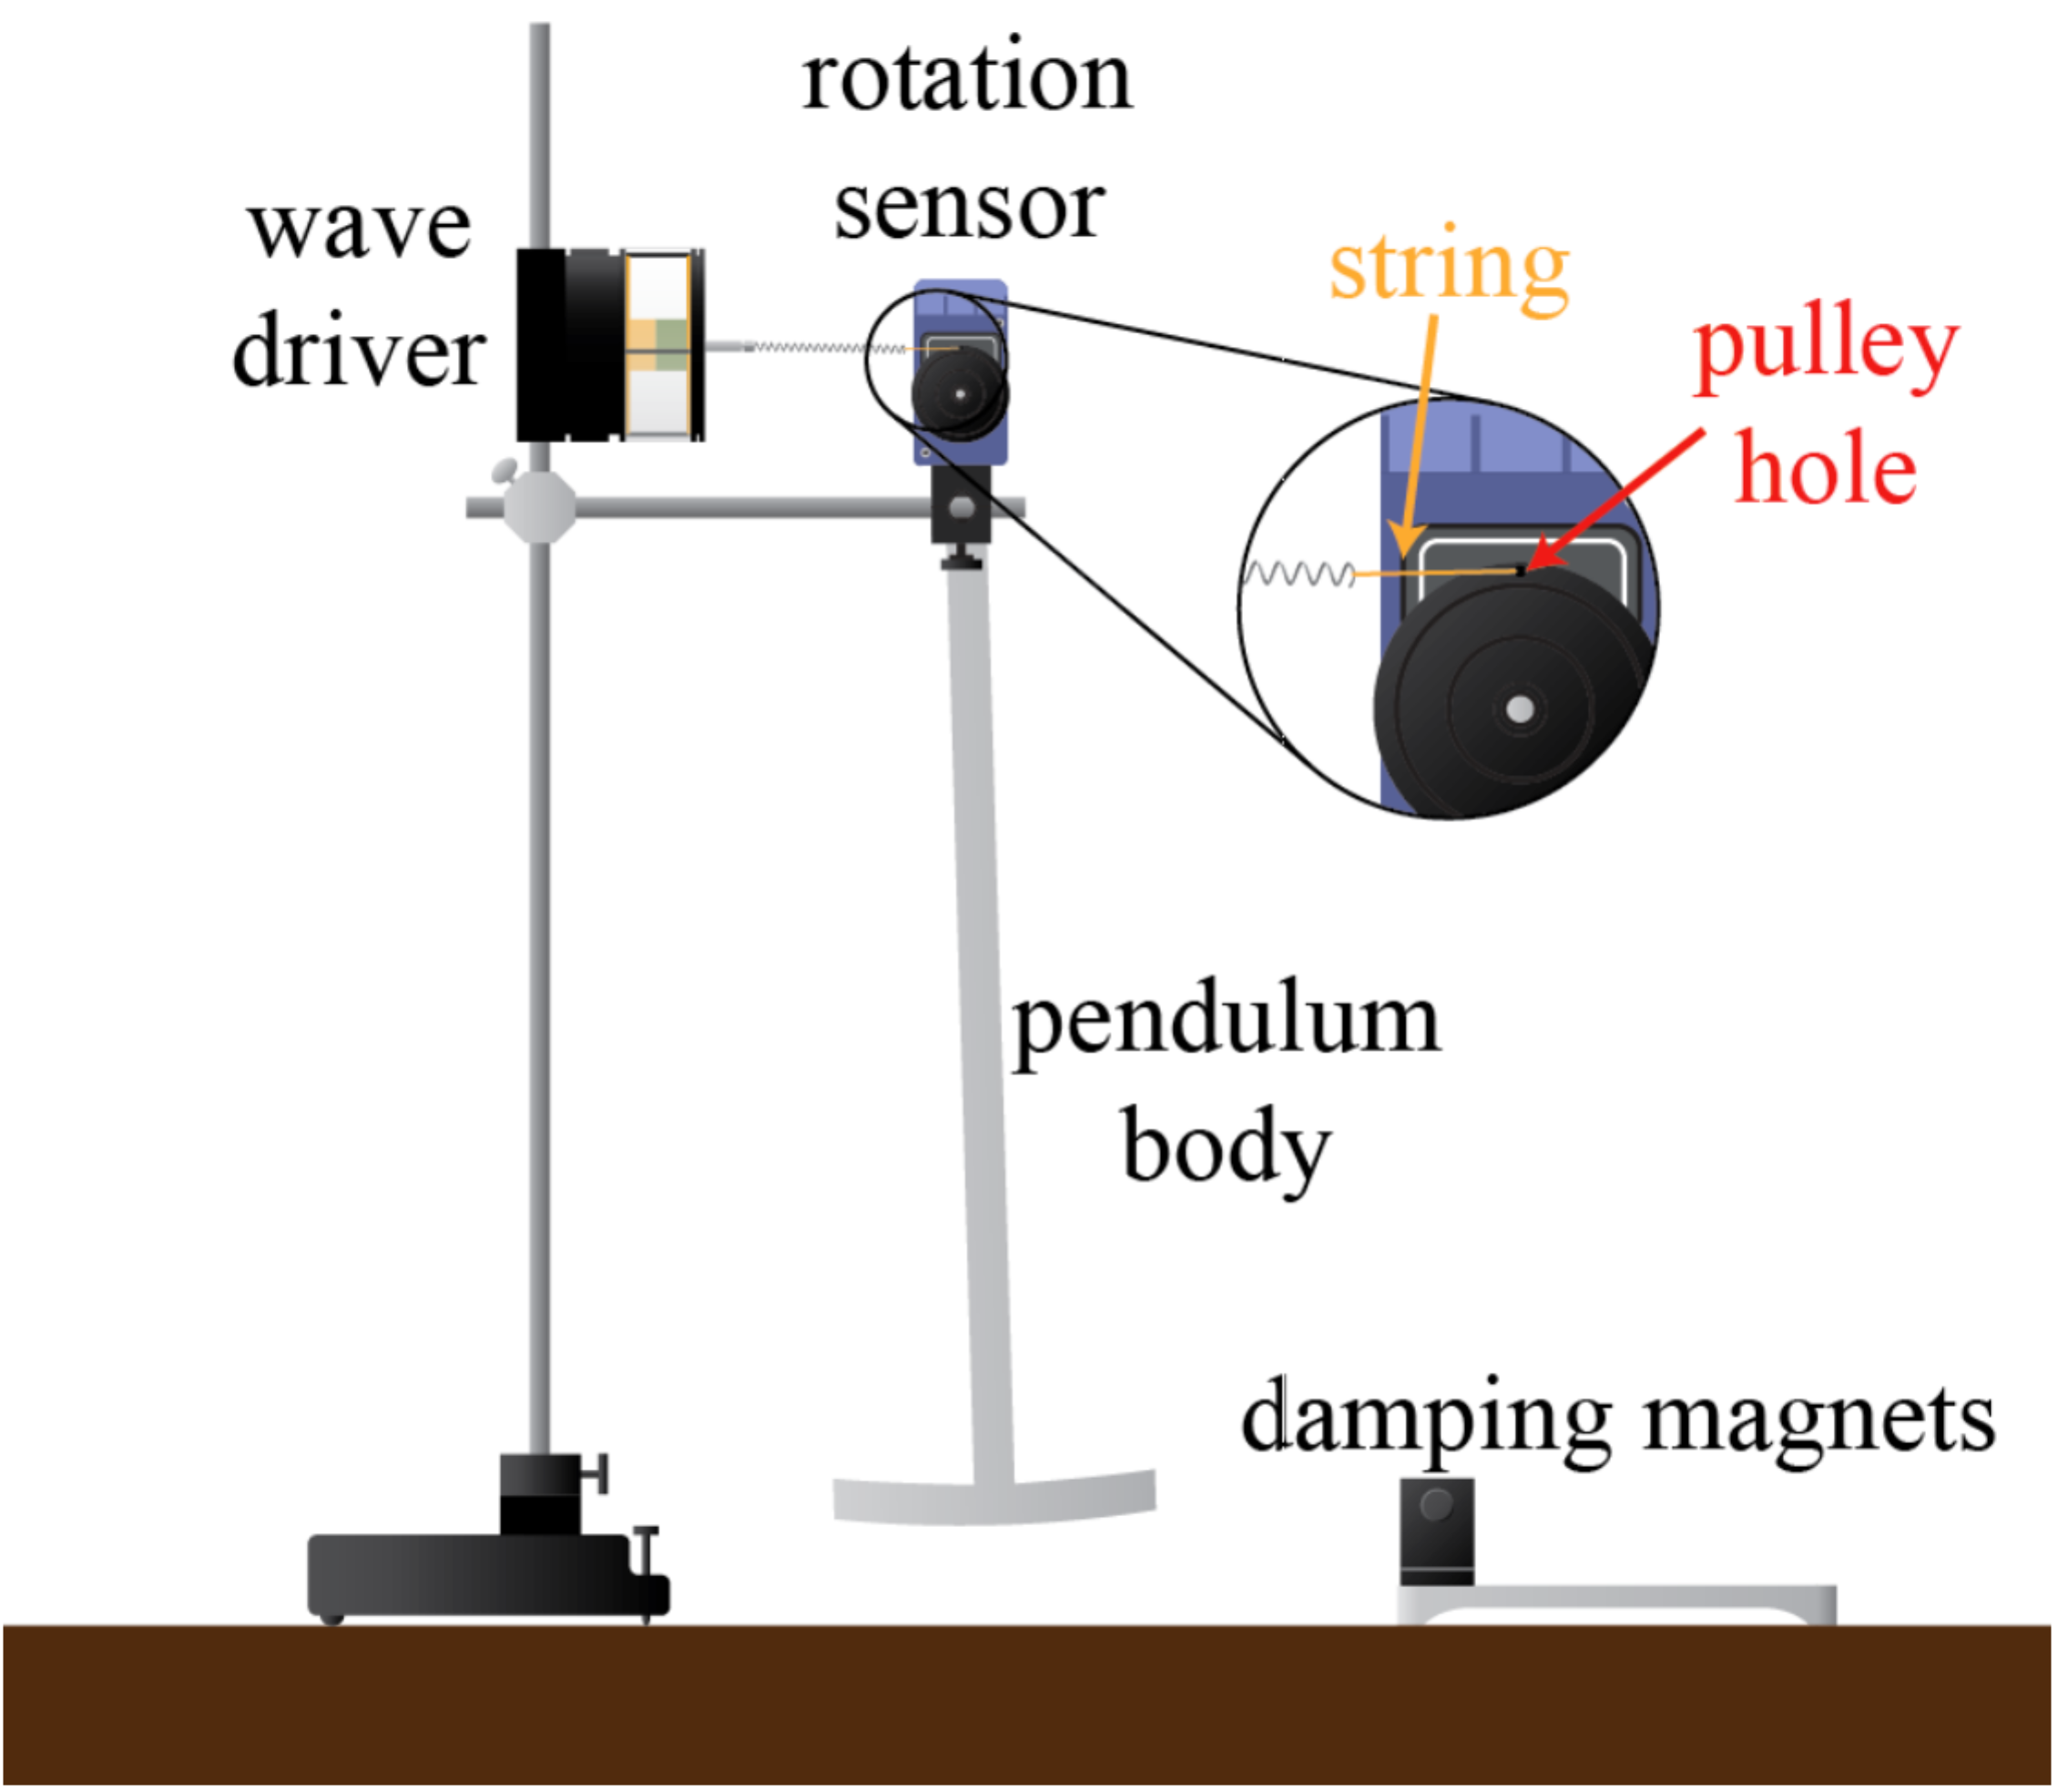

Figure : Experiment Setup: This image depicts the setup of the experiment. A metallic pendulum was attached to a rotation sensor, which was connected to a wave driver by using a spring. This setup allowed for the angle of the pendulum to be recorded during oscillatory motion through the use of a data acquisition system. By allowing the pendulum to swing between two magnets, damped oscillations could be observed. In order to produce stronger damping forces, the magnets were brought closer together. The wave driver in the setup allowed for the driven oscillations to be established. (Source: UCLA Physics 4AL Lab Manual, v. 20)

During the experiment, data based on oscillatory motion of the pendulum was recorded for magnet gaps of 50, 40, 30, 20, and 10 millimeters in order to observe changes in motion based on multiple damping coefficients. In order to find the magnet gap that would produce critical damping of the system, the relationships between underdamped and overdamped cases were analyzed. After adjusting the magnets and analyzing data based on oscillatory motion, it was seen that placing the magnets 14 ± 1 mm apart produced critical damping. The uncertainty in the measurement was based on the ruler that was used, which could measure distances to the nearest millimeter. Based on recorded data for underdamped, overdamped, and critically-damped cases, a graph was created to show the angle of the pendulum at regular time intervals, which could be seen in figure 2 below.

Figure : Effects of Damping on Angular Displacement: This graph shows plots of angular displacement over time for underdamping, overdamping, and critical-damping of the system. The data was shifted for each plot based on peak times and average angular displacement in order to have maximum angular displacement occur at the same starting time. In the underdamped case, the angular displacement changes sign multiple times over the recorded time interval. In the overdamped and critically-damped cases, the sign of angular displacement never changes, but the angle goes to zero much quicker in the critically-damped case.

In order to find the measured oscillation frequency “f0” of the pendulum when the magnets were removed, the recorded angular displacement and time data was used in equation 1.0, were “n” corresponds to the number of successive maxima that were used, and “Δt” is the difference in time between the first and last maxima. In order to find the uncertainty in the measurement, equation 1.1 was used, where frequency “fi” corresponds to the measured frequency between successive maxima. It was important to use as much recorded data as possible in an effort to minimize uncertainty. Based on the 8 successive maxima that were used in the calculations, the measured frequency “f0” was found to be 0.721 ± 0.004 Hz.

Before recording data during driven oscillations, the magnets were set 25 ± 1 mm apart in order to produce oscillations that completely damped out in about 10 seconds. A plot of the undriven oscillations based on this magnet gap is shown in figure 3 below.

Figure : Damping of Undriven Oscillator: This graph shows undriven oscillatory motion based on a magnet gap of 25 ± 1 mm, which causes complete decay of motion in less than 10 seconds. This amount of damping was chosen so that driven oscillations could be established within a short amount of time, while still producing distinctive oscillation amplitudes.

Based on the data shown in figure 3, the measured frequency with uncertainty could be calculated by using equations 1.0 and 1.1, where “n” corresponds to the number of successive maxima that were used in the calculations, “Δt” is the change in time between the occurrence of the first and last maxima, and “fi” is the frequency between every pair of successive maxima. Based on the 6 maxima that were used, the damped, undriven frequency was found to be 0.723 ± 0.005 Hz.

The damping time “ $τ$” with uncertainty “δ $τ$” could be calculated by using equations 1.3 and 1.4. In order to get a good calculation for “ $τ$”, equation 1.3 was used to calculate the damping time “i” for each successive period, and “ $τ$” was taken as the average of those values. The values “i” were used again in equation 1.4 to calculate the uncertainty based on the many values that were used. It was important to use as much data as possible in order to reduce the uncertainty in the calculation. Based on the 6 successive maxima that were used, the damping time “ $τ$” was found to be 1.2 ± 0.1 s.

In order to find the driven resonant frequency based on experimental data, the wave driver was used to drive oscillatory motion of the pendulum at specific frequency values. After allowing the pendulum to adjust to the motion of the wave driver, angle and output voltage data was recorded with a data acquisition system and used to create elliptical plots called Lissajous figures. The angle of the ellipse was used to visually see the deviation from the resonant frequency. If the ellipse was tilted downwards to the right as seen in figure 4, it indicated that the frequency was greater than the resonant frequency. Alternatively, if the ellipse was tilted downwards to the left as seen in figure 5, the frequency was less than the resonant frequency. Driving at the resonant frequency produced a symmetrical circular ellipse, as shown in figure 6 below.

Figure : Driving at Higher Frequency: This it a plot showing the Lissajous figure corresponding to a driving frequency of 0.727 Hz. Since the elliptical figure is tilted downward to the right, it indicates that the frequency is greater than the driven resonant frequency.

Figure : Driving at Lower Frequency: This it a plot showing the Lissajous figure corresponding to a driving frequency of 0.630 Hz. Since the elliptical figure is tilted downward to the right, it indicates that the frequency is less than the driven resonant frequency.

Figure : Driving at Resonant Frequency: This plot shows the Lissajous figure corresponding to a driving frequency of 0.701 Hz. Since the data points form a symmetrical circular figure, the plot indicates that the driving frequency is equal to the driven resonant frequency of the system. The uncertainty in this value could be found by altering the driving frequency until there is a noticeable change in the Lissajous figure. Based on experimental data, the uncertainty was found to be ± 0.001 Hz.

Based on the symmetrical plot in figure 6, the driven resonant frequency “fR” was found to be 0.701 ± 0.001 Hz. The uncertainty in this value is due to the fact that changing the driving frequency by more than 0.001 Hz caused a noticeable change in the generated Lissajous figure. In order to find the driven resonant frequency “ωR”, “fR” could be multiplied by 2π to get a value of 4.405 ± 0.006 rad/s. The uncertainty was found by multiplying the uncertainty “δfR” by the 2π in order to produce “δωR”.

By combining the driven resonant frequency “ωR” with the damping time, the quality factor “Q” with uncertainty could be calculated with equations 1.5 and 1.8. This gave a measurement of 2.6 ± 0.1. The uncertainty is based on the uncertainty of the resonant frequency “δωR” and the damping time “δτ”, along with equations 1.6 and 1.7.

Another method of calculating “Q” involves generating a resonance curve based on the oscillation amplitude of the pendulum corresponding to multiple drive frequencies around the resonant frequency. The generated curve based on 11 points is shown in figure 7 below.

Figure : Resonance Curve Based on Drive Frequencies: This plot shows the oscillation amplitudes of the pendulum corresponding to multiple drive frequencies around the resonant frequency of 0.701 ± 0.001 Hz. The amplitude was at its peak when the pendulum was driven at the resonant frequency. As the distance from the resonant frequency increased, the oscillation amplitude decreased. A resonance curve is shown connecting the data points, which can be used to find the width of resonance at a height of 1/ $\sqrt{2}$ of the maximum amplitude of 0.0155 radians.

In order to find the quality factor “Q” based on the resonance curve in figure 7, it was first necessary to find the width of resonance at a height of $1/\sqrt{2}$ times the maximum amplitude. Since the maximum amplitude was 0.0155 radians, the width of resonance should be measured at a height of 0.011 radians. In order to get the measurements, it is possible to change the scale for each axis on the graph in order to get accurate readings at the specified height. To change the scale, the axis options can be opened in Microsoft Excel, and the “major unit” option can be altered. By changing the scale of the vertical axis to 0.001 radians, and the scale of the horizontal axis to 0.01 Hz, measurements of frequency at a height of 0.011 radians could be found. These values could be found with minimal uncertainty by decreasing the frequency as much as possible. At this height on the graph, the left side of the curve corresponded to a frequency of 0.55 ± 0.05 Hz, and the right side of the curve corresponded to a frequency of 0.84 ± 0.04 Hz. The uncertainty in these points is based on the distances of the frequencies to the frequencies of the nearest recorded points (0.5 Hz and 0.8 Hz). Based on these values, the full width of resonance “Δf” is 0.29 ± 0.09 Hz. This can be converted to angular frequency by multiplying by 2π in order to find that the width of resonance “Δω” is 1.8 ± 0.6 rad/s.

By using the values “ωR” and “Δω”, and uncertainties “δωR” and “δΔω”, in equations 1.9 and 2.1, the quality factor “Q” can be found with uncertainty “ΔQ”. This gives a value of 2.4 ± 0.7.

Based on the calculated quality factor values of 2.6 ± 0.1 and 2.4 ± 0.7, it can be seen that the values generated with the two different methods agree with each other based on the calculated uncertainties. Since both methods rely on the same resonant frequency, the difference in the values is based on how well the damping time and the width of resonance can be calculated. Since the uncertainty in the width of resonance was high, the second method for calculating “Q” based on equations 1.9 and 2.1 was worse in this case than the first method involving equations 1.5 and 1.8. However, if more data points were used, the uncertainty in both methods could be greatly reduced, making both methods viable options.

**Conclusion**

The purpose of this experiment was to observe the effects of damping on a harmonic oscillator, and to explore resonance in a harmonic oscillator. By showing plots of the pendulum’s angular displacement over time for different magnet gaps, varying amounts of damping were demonstrated. This allowed for data to be recorded and displayed for damped, undamped, and critically-damped oscillations. In addition, after recording data based on driven oscillations, the quality factor “Q” was calculated based on two methods. One method involved using equations 1.5 and 1.8 with the resonant frequency “ωR” and the damping time “τ”, while the other method involved using equations 1.9 and 2.1 with the resonant frequency “ωR” and the width of resonance “Δω” of the generated resonance curve. Since the calculated values of “Q” agreed with each other based on the uncertainty ranges, the effects of resonance during oscillation were effectively demonstrated.

One possible source of systematic uncertainty was due to misalignment of the spring with the top of the rotation sensor. If the spring was not perfectly aligned, some of the force during driven oscillations would have been directed in a different axis, causing smaller oscillation amplitudes to be observed. A large amount of misalignment would have caused a downward shift of the resonance curve in figure 7 due to the smaller amplitudes that would have been recorded. One way to minimize this source of uncertainty would be to look at the spring from multiple angles and adjust the spring so that it is perfectly aligned with the top of the rotation sensor.

Another source of systematic uncertainty was due to inaccuracy of the rotation sensor. Based on data that was recorded by the data acquisition system, it was seen that many of the recorded angles were exactly the same for different time intervals. The inaccuracy of the sensor would have caused smaller oscillation amplitudes to be recorded based on the peaks of angular displacement, which may have caused a smaller damping time to be calculated. In order to minimize this uncertainty, a more accurate rotation sensor could be used in the experiment.